Assignment 3



|  |  |  |  |  |  |  |
| --- | --- | --- | --- | --- | --- | --- |
| Dataset | | | | | |  |
| x | 1 | 2 | 3 | 4 | 5 | x<=2.5 -> y=-1 |
| y | -1 | -1 | 1 | 1 | -1 | x>2.5 -> y=1 |
|  |  |  |  |  |  |  |
| Round 1 | | | | | |  |
| x | 1 | 1 | 2 | 4 | 5 | x<=0.5 -> y=-1 |
| y | -1 | -1 | -1 | 1 | -1 | x>0.5 -> y=1 |
|  |  |  |  |  |  |  |
| Round 2 | | | | | |  |
| x | 3 | 3 | 4 | 4 | 5 | x<=4.5 -> y=1 |
| y | 1 | 1 | 1 | 1 | -1 | x>4.5 -> y=-1 |
|  |  |  |  |  |  |  |
| Round 3 | | | | | |  |
| x | 1 | 2 | 2 | 5 | 5 | x<=0.5 -> y=-1 |
| y | -1 | -1 | -1 | -1 | -1 | x>0.5 -> y=-1 |
|  |  |  |  |  |  |  |
| Round 4 | | | | | |  |
| x | 1 | 3 | 4 | 4 | 5 | x<=2 -> y=-1 |
| y | -1 | 1 | 1 | 1 | -1 | x>2 -> y=1 |
|  |  |  |  |  |  |  |
| Round 5 | | | | | |  |
| x | 1 | 2 | 3 | 3 | 4 | x<=2.5 -> y=-1 |
| y | -1 | -1 | 1 | 1 | 1 | x>2.5 -> y=1 |

|  |  |  |  |
| --- | --- | --- | --- |
| Round | Split Point | Left Class | Right Class |
| 1 | 3 | -1 | 1 |
| 2 | 4.5 | 1 | -1 |
| 3 | 0.5 | -1 | -1 |
| 4 | 2 | -1 | 1 |
| 5 | 2.5 | -1 | 1 |

|  |  |  |  |  |  |
| --- | --- | --- | --- | --- | --- |
| Round | 1 | 2 | 3 | 4 | 5 |
| 1 | -1 | -1 | -1 | 1 | 1 |
| 2 | 1 | 1 | 1 | 1 | -1 |
| 3 | -1 | -1 | -1 | -1 | -1 |
| 4 | -1 | -1 | 1 | 1 | 1 |
| 5 | -1 | -1 | 1 | 1 | 1 |
| Sign | -1 | -1 | 1 | 1 | 1 |

|  |  |  |  |  |  |  |
| --- | --- | --- | --- | --- | --- | --- |
| Dataset | | | | | |  |
| x | 1 | 2 | 3 | 4 | 5 | x<=2.5 -> y=1 |
| y | 1 | 1 | -1 | -1 | 1 | x>2.5 -> y=-1 |
|  |  |  |  |  |  |  |
| Round 1 | | | | | |  |
| x | 1 | 2 | 3 | 4 | 4 | x<=2.5 -> y=1 |
| y | 1 | 1 | -1 | -1 | -1 | x>2.5 -> y=-1 |
|  |  |  |  |  |  |  |
| Round 2 | | | | | |  |
| x | 5 | 5 | 5 | 5 | 5 | x<=0.5 -> y=1 |
| y | 1 | 1 | 1 | 1 | 1 | x>0.5 -> y=1 |
|  |  |  |  |  |  |  |
| Round 3 | | | | | |  |
| x | 3 | 3 | 4 | 4 | 5 | x<=4.5 -> y=-1 |
| y | -1 | -1 | -1 | -1 | 1 | x>4.5 -> y=1 |

|  |  |  |  |  |  |  |  |  |
| --- | --- | --- | --- | --- | --- | --- | --- | --- |
| Round | Split Point | | Left Class | | Right Class | | | alpha |
| 1 | 2.5 | | 1 | | -1 | | | 1.589 |
| 2 | 0.5 | | 1 | | 1 | | | 2.113 |
| 3 | 4.5 | | -1 | | 1 | | | 3.015 |
| Weights | | | | | | | | | | |
| Round | | 1 | | 2 | | 3 | 4 | | | 5 |
| 1 | | 0.2 | | 0.2 | | 0.2 | 0.2 | | | 0.2 |
| 2 | | 0.036 | | 0.036 | | 0.036 | 0.036 | | | 0.857 |
| 3 | | 0.006 | | 0.006 | | 0.42 | 0.42 | | | 0.147 |

|  |  |  |  |  |  |
| --- | --- | --- | --- | --- | --- |
| Round | 1 | 2 | 3 | 4 | 5 |
| 1 | 1 | 1 | -1 | -1 | -1 |
| 2 | 1 | 1 | 1 | 1 | 1 |
| 3 | -1 | -1 | -1 | -1 | 1 |
| sum | 0.687 | 0.687 | -2.491 | -2.491 | 3.539 |
| sign | 1 | 1 | -1 | -1 | 1 |

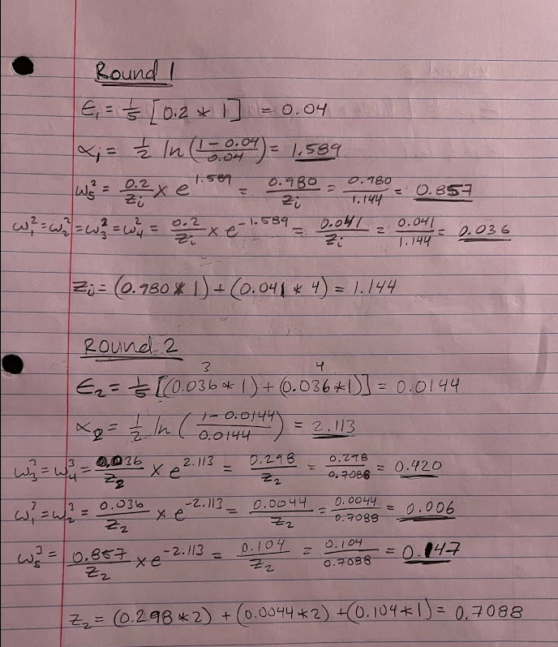

1. 3
   1. With the support vectors being (4,3), (6,5) and/or (8,3)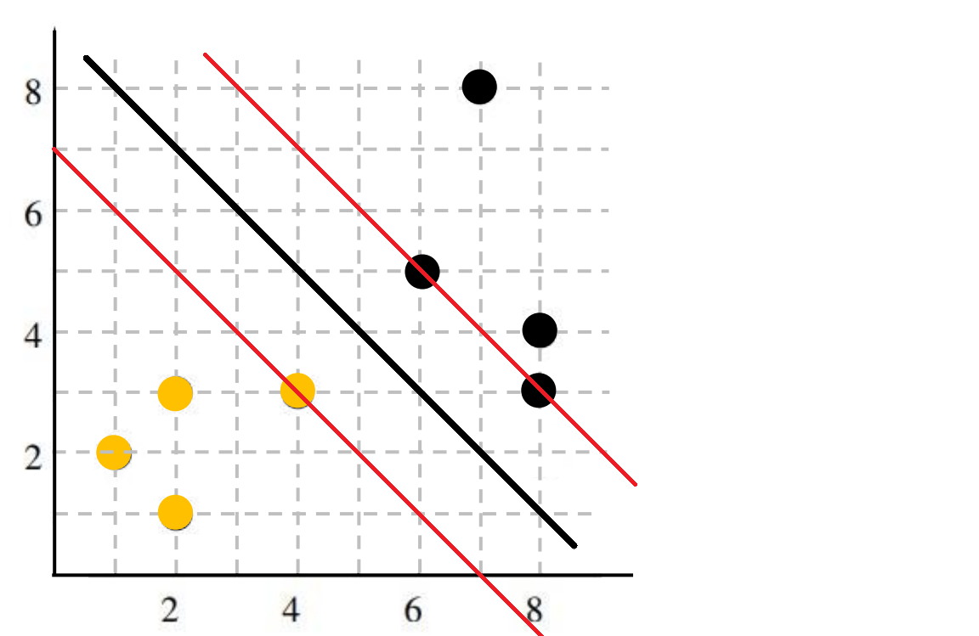
   2. No, because it is not in between the hard margin.
   3. No, because again it does not enter between the hard margins.
   4. Yes, because all instances above the decision boundary will be classified as black.
   5. Yes, because it is still above the decision boundary.
   6. Yes, because all instances below the decision boundary will be classified as yellow.
   7. Yes, it is still below the decision boundary.
   8. No, it will be classified as yellow because it is below the decision boundary.
   9. No, it will be classified as black because it is above the decision boundary.
   10. When C=1, the black circle will be a violation but would likely not affect the margins since this would be a soft margin. When C=∞, then this will move the top margin to the inserted black circle at (4,4) and make that the new support vector since this would be a hard margin.
   11. The decision boundary is 0.5 and the support vectors are 0 and 1.
   12. b = -1, w = 2.
   13. image
   14. b = -1, w = 2.

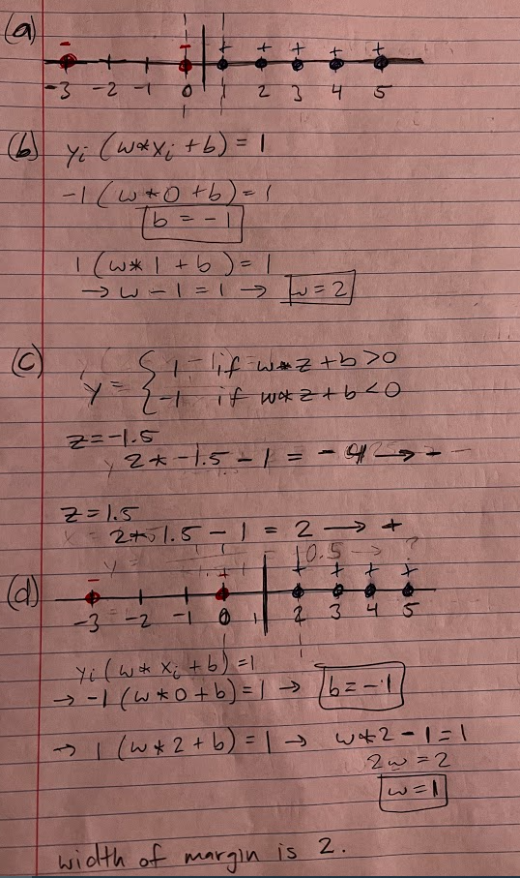

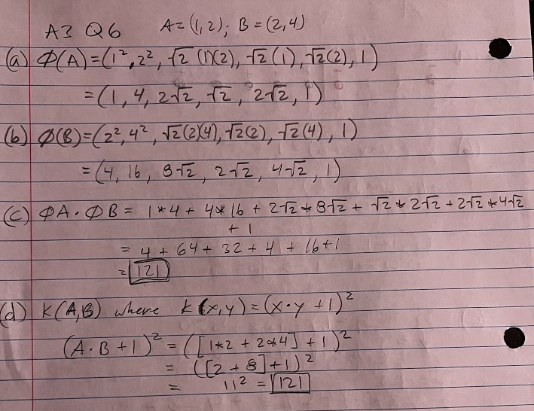

1. 7